First Hour Exam Vertebrate Embryology Feb 5, 2018 Your Name__________________

- The process in which mesodermal cells move into the interior of early developing embryos is called ________________________.

2) Would you expect the first polar body to be haploid, diploid or tetraploid?

3) List and describe important similarities between sea urchin development and mammal development.

4) Please sketch a sea urchin embryo late during the process of gastrulation.
On this sketch, label the locations of the blastopore,
the blastocoel, the archenteron, the primary mesenchyme,
the stomodeum and the animal pole. (Write each of these
words, and draw an arrow from the word to the location of
each of these structures.)

5) What is the difference between holoblastic versus meroblastic cleavage?

6) Please draw cross-sections of teleost embryos in at least 3 stages of development.

7) Fertilization of dog oocytes occurs when, relative to the first and second meiotic divisions?

8) Embryos of which kinds or animals have a yolk sac and an amnion?

9) If a pair of human identical twins developed inside the same chorion, but inside separate amniotic cavities (= "bag of waters"), then sketch how twinning occurred.

10) Mammal embryos cleave like _____________ embryos but gastrulate like __________________ embryos.

11) Who discovered embryonic induction in amphibian embryos ________________
Who discovered embryonic induction in nematode embryos? _________________
12) Neurulation subdivides which one of the three primary germ layers? ______________

13) What is the key difference between osmosis and electroosmosis?
What is the key similarity between osmosis and electroosmosis?

14) Describe at least four different kinds of amoeboid locomotion. Which of these have cytoplasmic flow? Which kinds of amoebae have membranes outside the cells?

15) Label a) through g) in this figure:

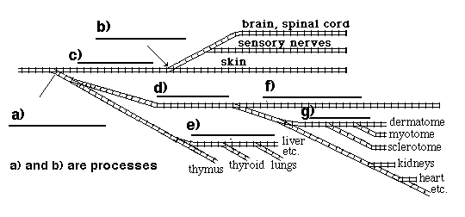

16) What is different about the formation of the neural tube in teleost fish, in comparison with neural tube formation in (almost) all other vertebrates?

17) Name two important organs that develop from mesoderm._______________, _________________

18) How much of our skeleton starts out being made out of cartilage, instead of bone?

19) Name two body parts that develop by inflation of hollow cavities with water. ___________ , _____________

20) This drawing shows an embryo of what kind of animal at what stage of development?

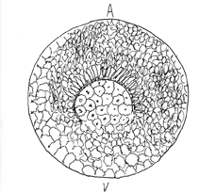

On my honor I have neither given nor received any unauthorized help on this exam

(Signed)_________________________________

