Second Exam Vertebrate Embryology Mar 2, 2018 Your Name______________________

1) Another name for the pronephric duct is________________________________

2) During embryonic development, the pronephric duct transports urine from ____________
to the cloaca.

3) In mammals the cloaca becomes subdivided into the rectum and the __________________?

4) What transient embryonic structures control the locations of sensory nerve ganglia? ________________

5) These same transient embryonic structures subdivide themselves into what four parts?
__________________, __________________, __________________, ___________________

6) The lens placode develops as a thickening in what subdivision of which of the three germ layers?__________________.

7) The semicircular canals of the inner ear develop from what?______________________?

8) In embryonic birds and reptiles, the diameter of the neural tube is [narrower/broader] than the diameter of its notochord? ____________________

9) The inner, bone-like dentine of teeth is produced by cells from which subdivision of which germ layer?____________________________

10) The angular change in direction, per distance along a line or a solid surface is called the ___________.

11) Change in Pressure is equal to tension in a flexible surface multiplied times what other second order tensor variable? ______________________________

12) The eustachian tube develops from what embryonic structure? __________________.

13) A pediatrician in Florida used what he had learned in an Embryology course to figure out why a certain birth defect resulted in a combination of weak immune systems and not enough parathyroid hormone. Previously, scientists had guessed that the explanation was that calcium somehow controlled immunity. What different theory was figured out by this pediatrician?

_____________________________________________________________________________.

14) Why don't birds sometimes have the birth defect called cleft palates?

15) What combination of two symmetries does a snail shell have?

16) Suppose there are two diffusible transcription factors, named Wxy and Tuv; and that Wyx stimulates synthesis of both, while both are destroyed at a rate proportional to the local concentration of Tuv. Then what additional property would Wxy and Tuv need to have in order for them to be able to create wave-like patterns of increasing and decreasing concentrations?

17) Label the parts in the cross section below, including what organ or tissues each part will develop into.

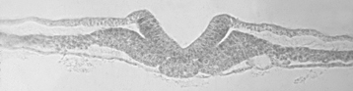

18) The diagram below summarizes what embryological phenomenon? Please label the parts.

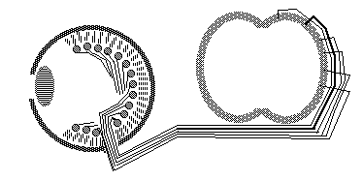

19) Name the symmetry of every capital (uppercase) letter of the alphabet, in groups of symmetry type. For example, the letter A has one plane of reflection symmetry. List the other letters that have this symmetry. Which letters have two planes of reflection symmetry? Continue with all the other possible symmetries until you have accounted for every letter.

20) Which of the following develop from previously adjacent epithelial cell sheets?
a) The neural retina and the pigmented retina of the eye?
b) The neural crest and the neural tube?
c) The enamel secreting cells of your teeth and the skin covering your gums?
d) The alveoli of your lungs and the cells lining your throat?
e) The lens of your eyes and the cornea covering your lens?
f) All of the above?

On my honor, I have neither given nor received any unauthorized help. (sign)

